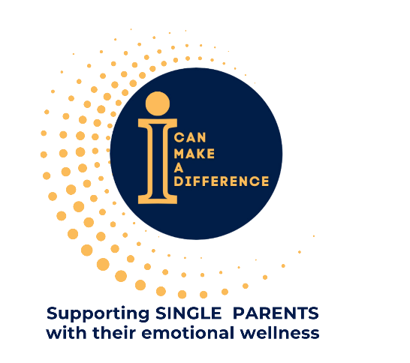
2024 Annual Report
“Alone we can do so little; together we can do so much." - Helen Keller

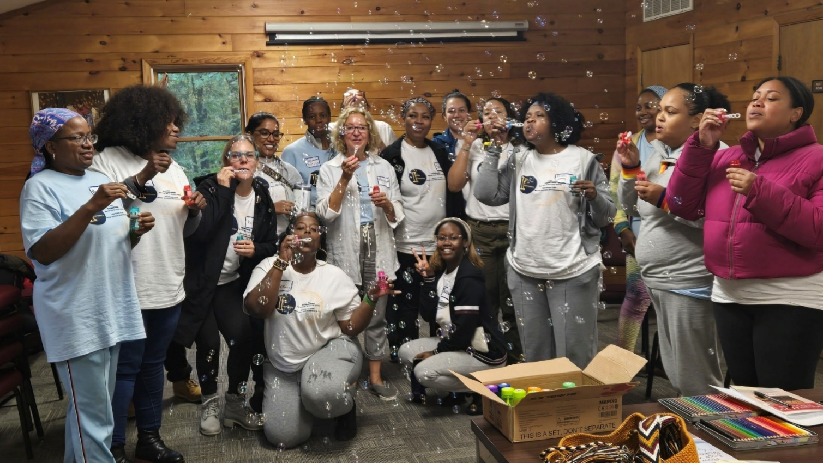

Investing in Strengthening Single Parent Families Emotional Wellness

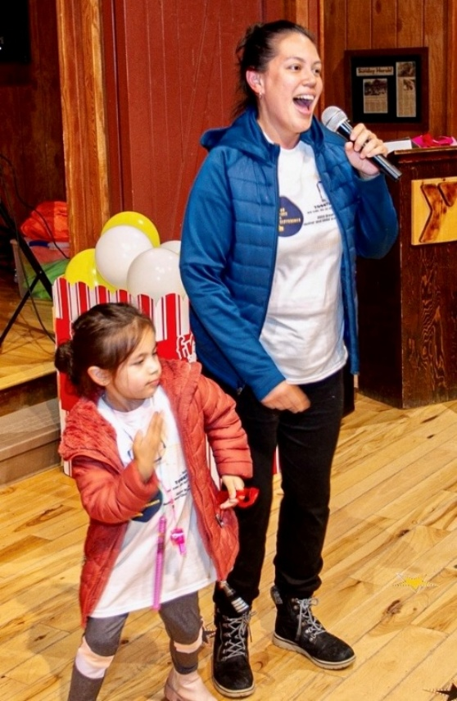
Navigating single parenthood can be an incredibly challenging experience, often filled with feelings of isolation and emotional strain. Research from the National Institutes of Health (NIH) indicates a significant link between parents' emotional well-being and their children's development.

At iCMAD, we believe that every single parent deserves access to the support and tools that can help them navigate these challenges. Our programs provide counseling, support groups, and workshops focused on emotional resilience, self-care, and community building.

Our Story So Far

iCMAD’s work began before we became a 501(c)(3) in May 2023. We started in 2015 with a Winter Coat Drive to collect 250 winter coats for unhoused individuals and ended up distributing over 2500 coats and warm clothing. That same year we held our first annual Break Free Women's Conference to provide a sanctuary for underrepresented women. In 2019, we held our first annual Mother and Child Weekend Retreat, a natural extension of the Break Free Conference. In 2020, we launched our weekly Single Parent Support Group, a safe place to connect with other single parents. In 2023, we launched our Pass the Purse, Please program which is an interactive, fun-filled event focused on emotional wellness for single mothers.

Over the past two years, we have grown significantly. In 2024, iCMAD positively impacted over 700 women and children by providing programs and tools to foster emotional resilience and self-awareness and to better manage trauma and stress.
.

iCMAD Programs in 2024
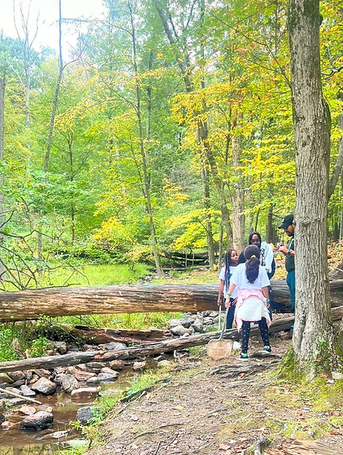

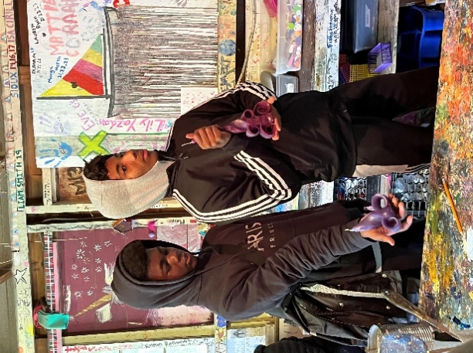
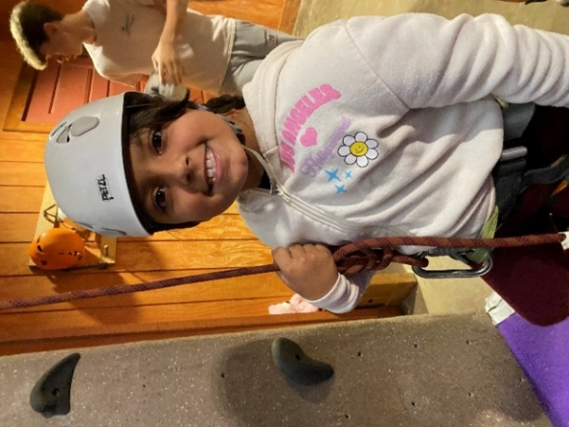

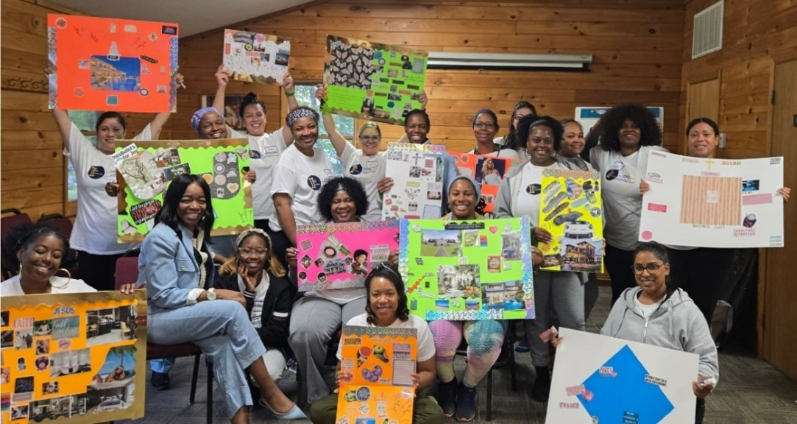

2024 Mother & Child Retreat

Our third collaboration with the Fairview Lake YMCA Camps provided 18

mothers and 22 children, ages 5-17, with a weekend away at camp. Activities included s'mores by the campfire, archery, boating, rock wall climbing, nature discovery hikes, and stream ecology lessons. Moms attended workshops focused on building communication and interpersonal skills and developing goals for the future. In 2025, a new program, Transforming Dreams into Reality, has built on the Vision Boards the mothers developed and provides coaching assistance to guide them toward achieving their goals.

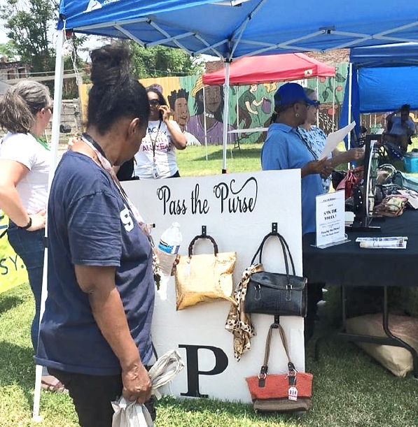
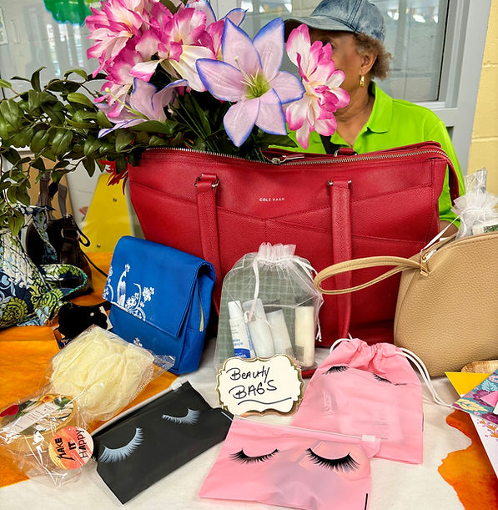

Pass the Purse, Please

Pass The Purse, Please is a wellness-focused program geared at giving women, particularly single parents, a hand-up by providing them with much-needed support and resources.

Every woman…

Participates in a fun activity designed to promote emotional wellness in a supportive and uplifting environment.

Receives a purse that contains beauty products, hygiene items, and other essentials that they may find helpful in their everyday lives.

Has the opportunity to pay it forward by spreading kindness and hope to other women by creating a card of encouragement for future participants.

In 2024 we held 16 Past the Purse, Please events in MO, NJ, PA, and NYC, at community centers, churches, and shelters, collecting over 700 purses filled with toiletries and distributed to approximately 500 women.

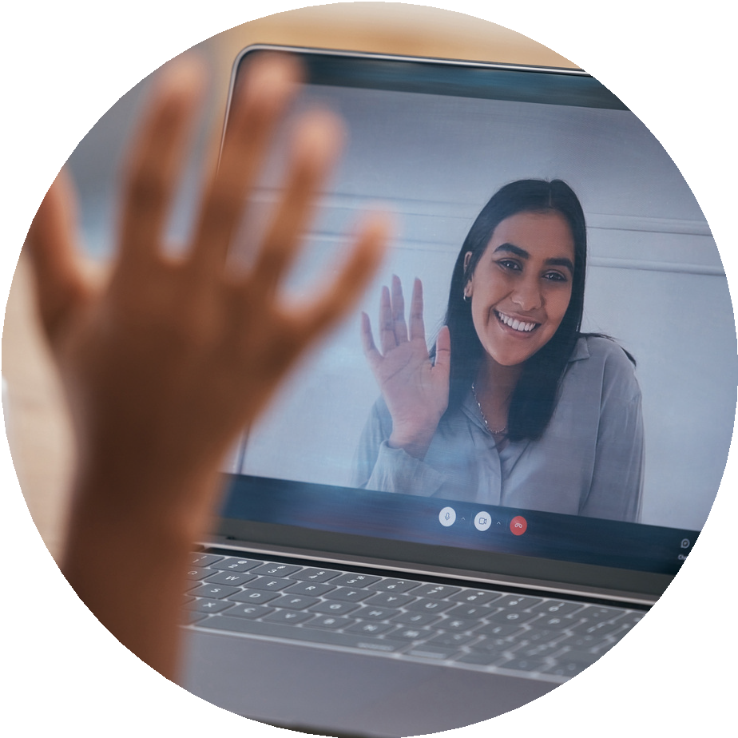
SINGLE PARENTS Support Group

For the past 4 years, iCMAD has hosted a virtual weekly support group for single parents, meeting every Wednesday evening. Discussions focus on topics that impact on the lives of the parents and their children. Examples of past topics include self-sabotage, living with integrity, and self-care.​​

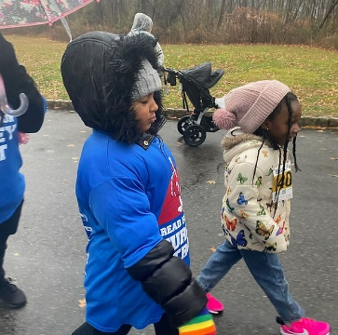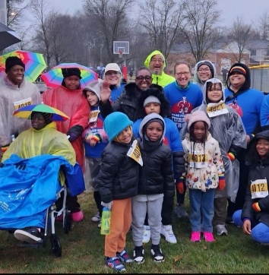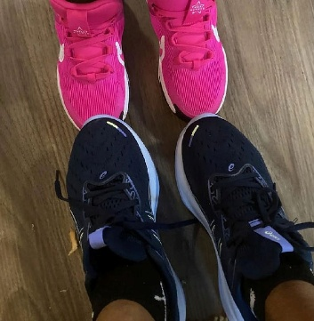

2024 Morriston, NJ Turkey Trot

iCMAD collaborated with the Amazing Feet Running Club and Fleet Feet of Westfield, NJ to launch this inaugural wellness event on Thanksgiving Day. A total of fifteen mothers and their children took part in the activity. Each participant received a new pair of running shoes, and one lucky mother received a running stroller for her baby.

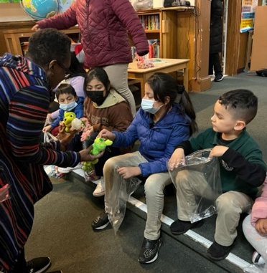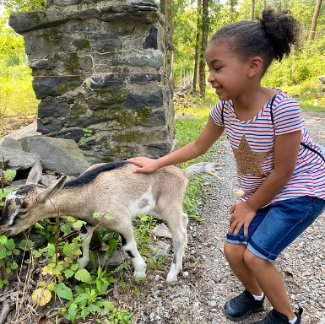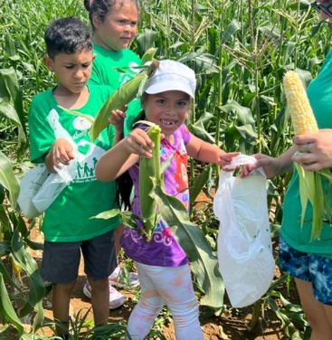

Bernice's Place

Bernice’s Place is a program of the Elizabeth Coalition to House the Homeless in Elizabeth, NJ, serving as a vital resource for homeless and at-risk children. This program offers a secure, enjoyable, and nurturing environment for children residing in shelters and temporary housing, featuring afterschool and summer camp programs designed to support their needs.

In 2024, iCMAD collaborated with Bernice’s Place on an 8-month initiative to promote healthy eating habits for the children in the afterschool program. This included educational trips to three farms to provide the children with an opportunity to learn about the origin of their food. Over 30 children, ages 6-13, participated in the farm tours. Additionally, through the generosity of many donors, we provided the children in the after-school program with healthy snacks during the school year. At the end of the school year, iCMAD hosted a party for the children where they shared what they learned through the initiative.

iCMAD Sponsors and Major Donors
Sponsors and Donors $5,000 and above

Fi

Buckner Family
Anonymous Matching Donor
Fairview Park YMCA
Sponsors and Donors $4,999 – $1,000

Fi

Nelson Lee
First Bank of New Jersey

Sponsors and Donors $999 - $250

Fi

Princeton Bank
St Ignatius of Antioch Episcopal Church
NJ Manufacturers Insurance
Dawn Forbes
Laurel Bishop & Nick Greendyk
Other donors that wishes to remain anonymous

Need data from Accountant then can make charts

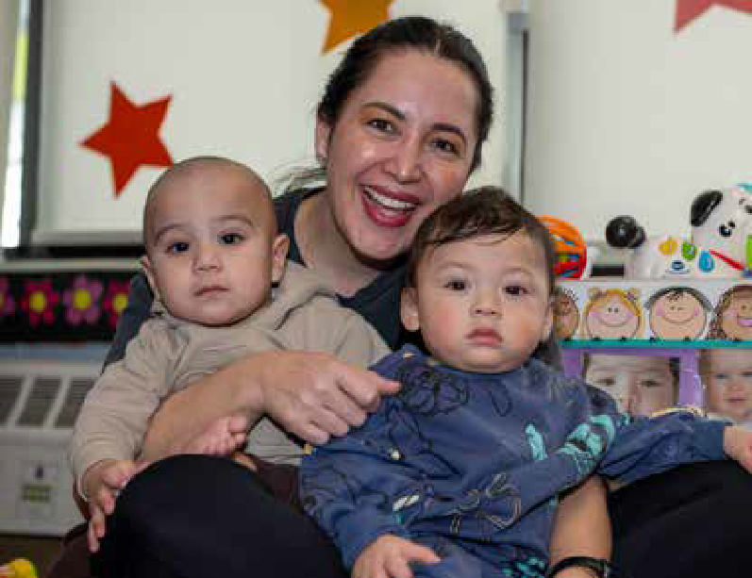
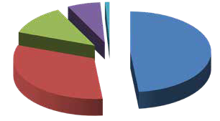
1
Revenue & Expenses
January 2024 - December 2024
Revenue
1. Contract and Grants | $3,256,760
2. Fees and Third Party | $2,163,226
3. Contributions | $813,822
4. Fund Raising | $445,983
5. Other Income | $60,586
Total Revenue | $6,740,377

2
3

 |  | 4
 |  | 5
Expenses
1. Personnel Costs | $5,191,710
2. Professional Fees | 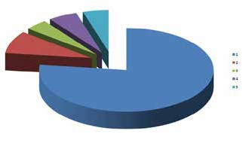  $326,265
3. Occupancy | $249,709
4. Materials & Supplies | $361,512
5. Other Expenses | $318,869
Sub total of program expenses | $6,448,065
Change in operations | $292,312
Depreciation expense | $141,826
Net change in value of investments | $95,925
Change in program assets | $246,411

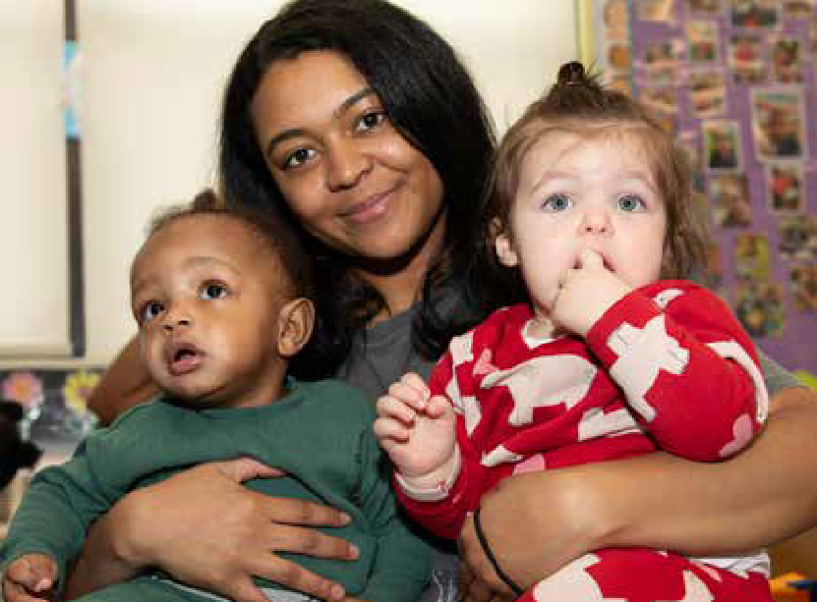
Impact

January 2023 - December 2024

Since becoming a 501(c)(3) in May 2023, iCMAD has grown in reach and impact on single-parent families and in contributions from our supporters in just two years.

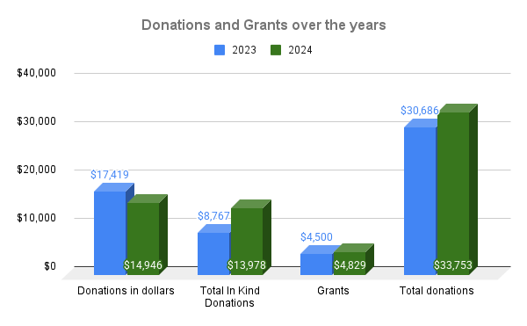

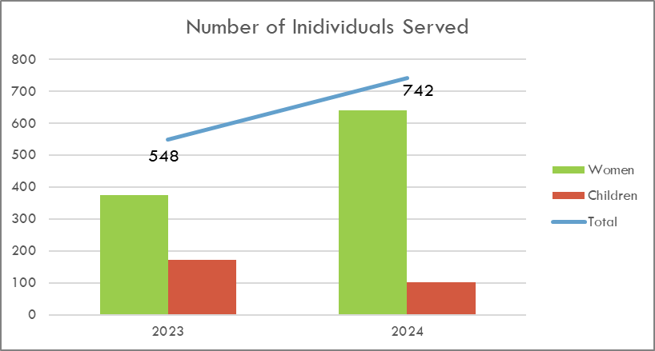

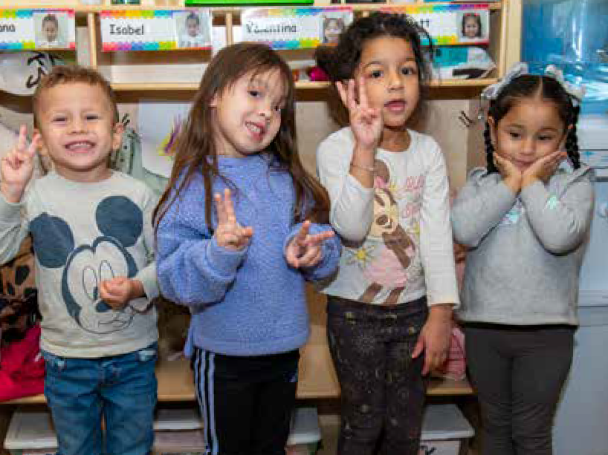
Board Members2024

Faith Saunders, Chair and Founder
Rehabilitation Counselor

Serene Longsworth, Co-Chair
Engineer

Clavel Nelson, Treasurer
Doctor of Nursing Practice

Ashley McCalla, Secretary
Project Manager

Sonja Bishop
Vocational Counselor

LaVerne Miller
Attorney

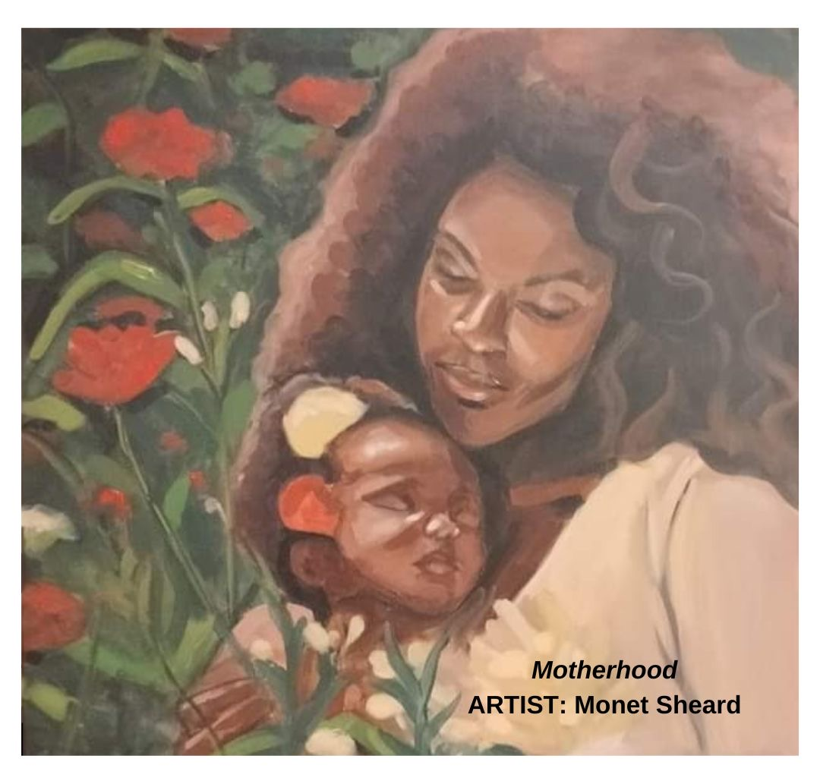

Stay in Touch

Email: info@icanmakeadifferencenow.org
Telephone: (201) 608 - 3004
Visit Us at: www.icanmakeadifferencenow.org
Instagram Linkedin Facebook

